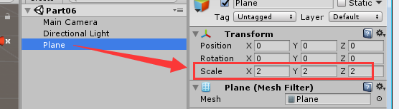

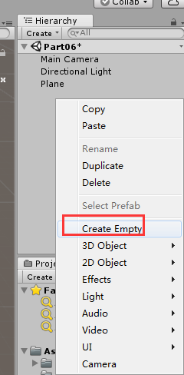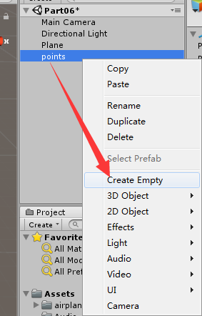

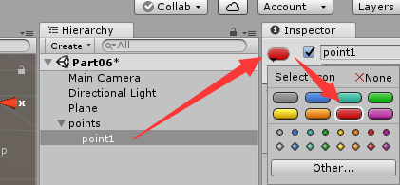

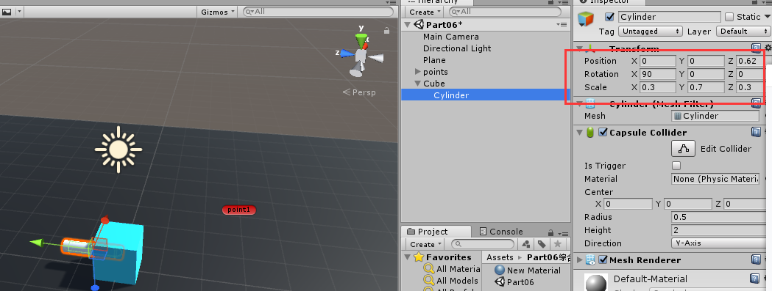

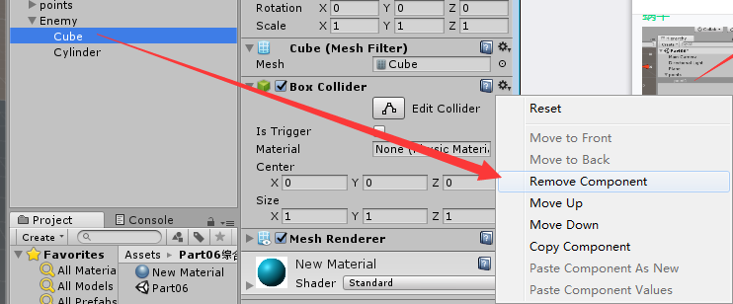

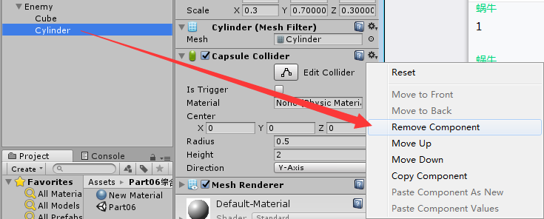

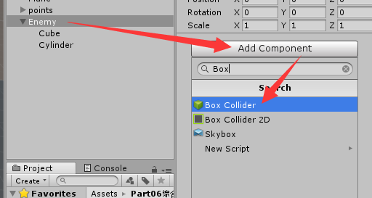

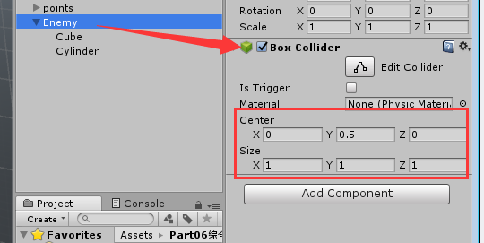

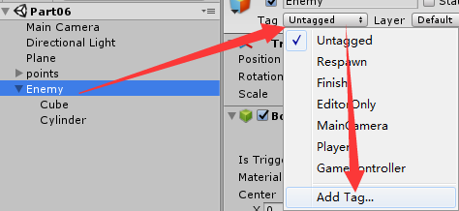

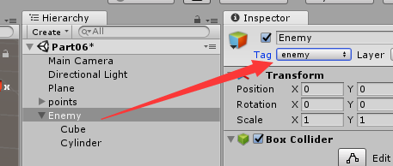

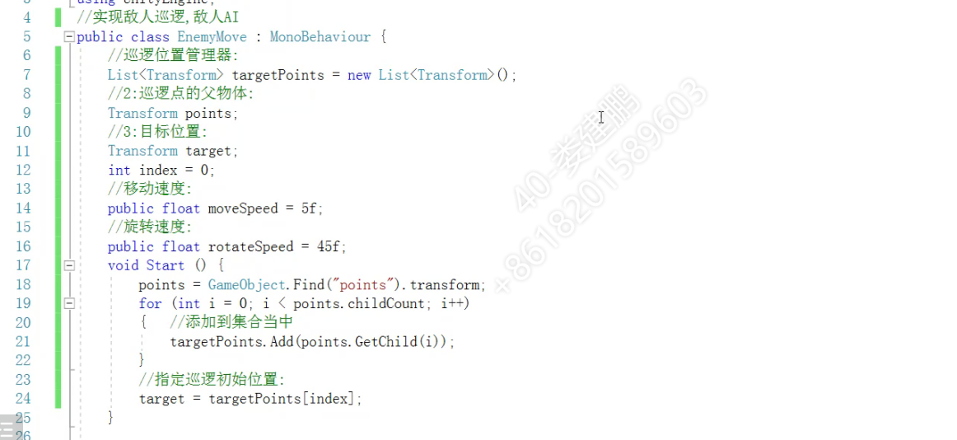

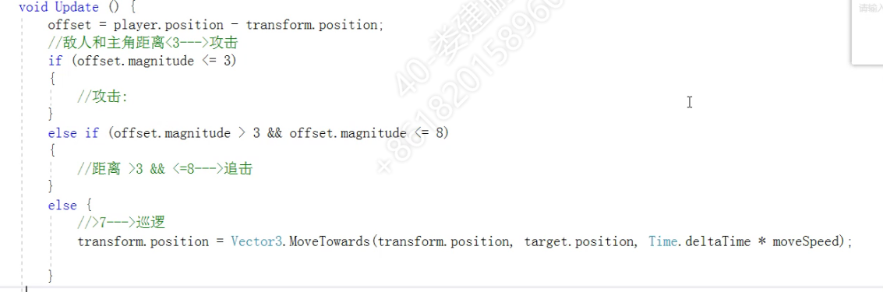

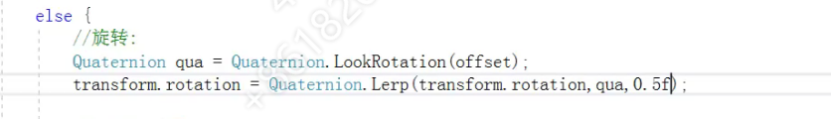

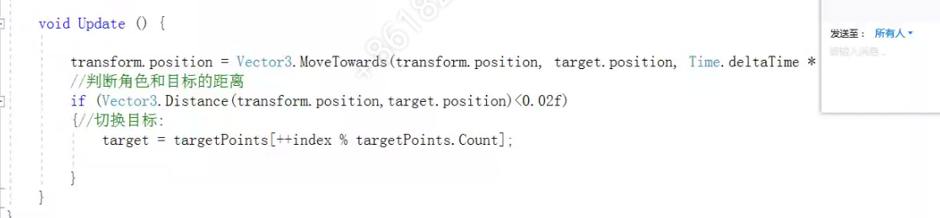

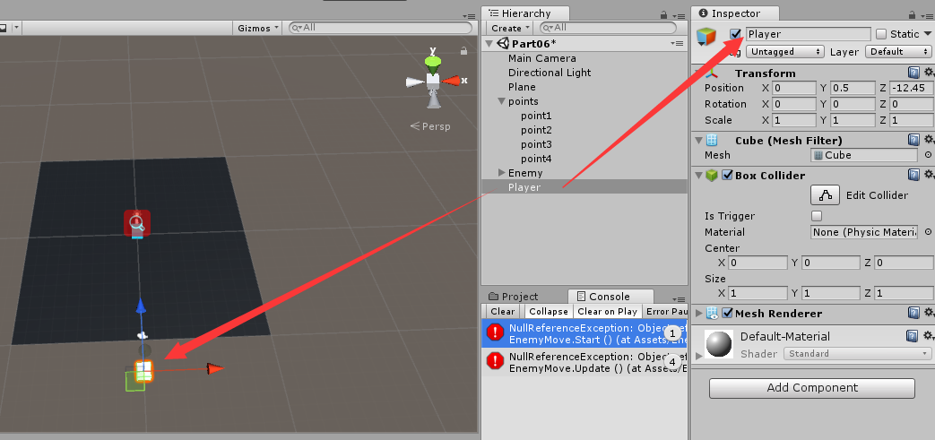

**代码：**

//实现敌人巡逻,敌人AI  
public class EnemyMove : MonoBehaviour {  
    //巡逻位置管理器:  
    List<Transform> targetPoints = new List<Transform>();  
    //2:巡逻点的父物体:  
    Transform points;  
    //3:目标位置:  
    Transform target;  
    int index = 0;  
    //移动速度:  
    public float moveSpeed = 5f;  
    //旋转速度:  
    public float rotateSpeed = 45f;  
    Transform player;  
    Vector3 offset;  
void Start () {  
        player = GameObject.Find("Player").transform;  
        points = GameObject.Find("points").transform;  
        for (int i = 0; i < points.childCount; i++)  
        {   //添加到集合当中  
            targetPoints.Add(points.GetChild(i));  
        }  
        //指定巡逻初始位置:  
        target = targetPoints[index];  
}  
  
void Update () {  
        offset = player.position - transform.position;  
        //敌人和主角距离<3--->攻击  
        if (offset.magnitude <= 3)  
        {   //强制看向人物  
            transform.LookAt(player.position);  
            //攻击:  
            Debug.Log("Attack!!");  
        }  
        else if (offset.magnitude > 3 && offset.magnitude <= 8)//追击  
        {  
            Quaternion qua = Quaternion.LookRotation(offset);  
            transform.rotation = Quaternion.Lerp(transform.rotation, qua, 0.5f);  
            transform.position = Vector3.MoveTowards(transform.position, player.position, Time.deltaTime * moveSpeed);  
        }  
        else {  
            //旋转:  
            Quaternion qua = Quaternion.LookRotation(target.position - transform.position);  
            transform.rotation = Quaternion.Lerp(transform.rotation,qua,0.5f);  
            //巡逻  
            transform.position = Vector3.MoveTowards(transform.position, target.position, Time.deltaTime * moveSpeed);  
        }  
        //判断角色和目标的距离  
        if (Vector3.Distance(transform.position,target.position)<0.02f)  
        {//切换目标:  
            target = targetPoints[++index % targetPoints.Count];  
        }  
}  
}

